Government Notice No157 of 2001

THE ENVIRONMENT PROTECTION ACT 1991

Regulations made by the Minister under sections 37 and 74
of the Environment Protection Act 1991

1. These regulations may be cited as the Environment Protection (Standards for hazardous wastes) Regulations 2001.

2. In these regulations-

"Act" means the Environment Protection Act 1991;

"carrier" in relation to a consignment of hazardous waste, means the person who collects that waste from the premises at which it is being held and transports it to another place;

"consignee" in relation to a consignment of hazardous waste, means the person to whom that waste is to be transported to;

"consignor" in relation to a consignment of hazardous waste, means the person who causes that waste to be removed from the premises at which it is being held;

“disposal site” means a site approved by the enforcing agency as a site for disposal of hazardous wastes;

“export” means to take or cause to be taken out of Mauritius;

"hazardous waste" means any waste -

- specified in the third column of the First Schedule in respect of the corresponding waste stream specified in the second column of that Schedule; or

- having as constituents one of the substances specified in the Second Schedule,

and displaying any of the hazardous properties specified in the Third Schedule;

“import” means to bring or cause to be brought into Mauritius from any country;

“incompatible hazardous waste” means any waste specified in Group A or Group B of the Fourth Schedule which when mixed with a waste of Group B or Group A respectively may produce a potential consequence specified in the fourth column of that Schedule;

“pretreatment” means a process by which a hazardous waste is rendered inert and stable as far as practicable;

“waste generator” means a person whose industrial, commercial, research or treatment activity generates a hazardous waste.

- No person shall dispose of a hazardous waste –

  - at any place except at a disposal site; and

  - after such pretreatment as may be imposed by the enforcing agency prior to disposal.

4. A waste generator shall -

- minimize the generation of a hazardous waste by using the best practicable means;

- ensure that a hazardous waste is properly stored, treated on site or disposed of as approved by the appropriate enforcing agency.

- (1) No person shall use, store, transport or otherwise deal with a hazardous waste unless that hazardous waste is kept in a container or package -

(a) designed and constructed as to preclude spillage or leakage to the environment;

(b) the material of which is not be susceptible to attack by the waste or liable to form harmful compounds with that waste; and

- designed as to ensure safe, complete or partial emptying.

(2) No person shall store an incompatible hazardous waste except in a separate container.

6. (1) A waste generator or carrier shall ensure that any container in which a hazardous waste is stored or carried is labelled in accordance with the Fifth Schedule.

(2) Where a hazardous waste displays more than one of the qualifications specified in the Fifth Schedule, the waste generator or carrier shall ensure that the container displays labels showing each distinct qualification.

7. (1) No person shall use any store, warehouse or other premises for the storage of a container or package containing a hazardous waste unless he has obtained an approval from the relevant enforcing agency.

(2) Before granting any approval under paragraph (1), the enforcing agency must be satisfied that the store, warehouse or any other premises is of such design, construction and layout as to prevent spillage or leakage of the hazardous waste to the environment.

8. At the end of every quarter, a waste generator shall –

    - draw up, in accordance with the Sixth Schedule, an inventory of the quantity of hazardous waste generated, stored and disposed of by him; and

    - forward a copy of such inventory to the enforcing agency.

9. (1) Where a consignor delivers any hazardous waste to a carrier for the purpose of its treatment or disposal at a site approved by the enforcing agency, the consignor shall complete 6 copies of Part I of a consignment note in accordance with the Seventh Schedule and hand them over to the carrier.

(2) The carrier shall upon receiving the hazardous waste complete Part II of the 6 copies of the consignment note and forthwith hand over 2 copies to the consignor.

(3) The consignor shall retain one copy and send one copy of the consignment note to the enforcing agency.

(4) The carrier shall hand over the remaining 4 copies of the consignment note to the consignee.

(5) The consignee shall, upon receiving hazardous waste from the carrier, complete Part III of the remaining 4 copies of the consignment note and shall –

- retain one copy;
- hand over one copy to the carrier;
- forward one copy to the consignor; and
- forward one copy to the enforcing agency.

    - If a consignor fails to receive his copy of consignment note from the consignee within 7 days from the date of delivery of a hazardous waste, he shall forthwith notify the enforcing agency.

    - A carrier shall, at the request of a police officer, produce for examination, the consignment note in respect of the consignment of hazardous waste being transported by him.

10.

No person shall export a hazardous waste without the approval in writing of the enforcing agency.

11. No person shall import a hazardous waste.

12. These regulations shall come into force on 01 April 2002.

Made by the Minister on 01 October 2001.

FIRST SCHEDULE
(Regulation 2)

Hazardous wastes

 | Waste stream | Description of waste
1. | Batteries and accumulators | - Electrolyte from batteries and accumulators
 |  | - Lead batteries
 |  | - Mercury dry cells
 |  | - Ni-Cd batteries
2(a) | Electronic industry | - Chlorofluorocarbons
(b) | Coolants, foam / aerosol propellants | - Sludges or solid wastes containing solvents
(c) | Solvent and coolant recovery (still bottoms) | - Solvents
3. | Human or animal health care and research related to such health care | - Waste from diagnosis, treatment or prevention of disease and natal care.
4. | Leather and textile industries | - Degreasing wastes containing solvents without a liquid phase
 |  | - Halogenated wastes from dressing and finishing
5. | Manufacture, formulation, supply and use of adhesive and sealants (including water proofing products) | - Adhesives and sealants sludges  - Waste adhesives and sealants
6 (a) | Manufacture, formulation, supply and use of biocides and phyto-pharmaceuticals | - Aqueous washing liquids and mother liquors
(b) | Manufacture, formulation, supply and use of | - Contaminated packaging and containers
 | pharmaceuticals | - Date expired product
 |  | - Halogenated still bottoms and reaction residues
 |  | - Other still bottoms and residues
 |  | - Halogenated filter cakes, spent absorbents
 |  | - Other filter cakes, spent absorbents
 |  | - Organic halogenated solvents, washing liquids and mother liquors
 |  | - Other organic solvents, washing liquids and mother liquors
 | Waste stream | Description of waste
7. | Manufacture, formulation, supply and use of organic dyes and pigments | - Aqueous washing liquids and mother liquors
 |  | - Halogenated still bottoms and reaction residues
 |  | - Other still bottoms and residues
 |  | - Halogenated filter cakes, spent absorbents
 |  | - Other filter cakes, spent absorbents
 |  | - Organic halogenated solvents, washing liquids and mother liquors
 |  | - Other organic solvents, washing liquids and mother liquors
8(a) | Manufacture, formulation, supply and use of organic solvents and chemical products other than those specified in items 6(a), 6(b) and 7. | - Aqueous washing liquids and mother liquors  - Contaminated packaging and containers
(b) | Manufacture, formulation, supply and use of fats, grease, soaps, detergents, disinfectants and cosmetics | - Halogenated still bottoms and reaction residues  - Other still bottoms and residues
(c) | Manufacture, formulation, supply and use of | - Halogenated filter cakes, spent absorbents
 | plastics, synthetic rubber, and man-made fibre | - Other filter cakes, spent absorbents
 |  | - Organic halogenated solvents, washing liquids and mother liquors
 |  | - Other organic solvents, washing liquids and mother liquors
9. | Manufacture, formulation, supply and use of paint and varnish | - Sludges from paint or varnish removal  - Waste paints and varnish
10. | Manufacture, formulation, supply and use of printing inks | - Ink sludges  - Waste ink
11. | Metal surface treatment, such as etching, | - Cyanide free wastes containing chromium
 | cleaning, degreasing and hot dip galvanising | - Cyanidic waste
 |  | - Sludges

 | Waste stream | Description of waste
12. | Miscellaneous sources | - Acid tars
 |  | - Other tars
 |  | - Ammonia
 |  | - Calcium hydroxide
 |  | - Contaminated containers or other packaging
 |  | - Hydrochloric acid
 |  | - Hydrofluoric acid
 |  | - Nitric acid and nitrous acid
 |  | - Bilge oils
 |  | - Engine, gear, and lubricating oils
 |  | - Hydraulic oils and brake fluids
 |  | - Insulating and heat transmission oils containing PCBs or PCTs
 |  | - Mineral insulating and heat transmission oils
 |  | - Non-chlorinated insulating and heat transmission oils and other liquids
 |  | - Other chlorinated insulating and heat transmission oils and other liquids
 |  | - Oil/water separator contents (solids, sludge and emulsions)
 |  | - Oil spills
 |  | - Synthetic insulating and heat transmission oils and other liquids
 |  | - Phosphoric acid
 |  | - Sodium hydroxide
 |  | - Sulphurous acid and sulphuric acid
13. | Photographic industry | - Bleach solutions and bleach fixer solutions
 |  | - Fixer solutions
 |  | - Solvent based developer solutions
 |  | - Water based developer and activator solutions
 |  | - Water based offset plate developer solutions
 |  | - Water containing silver from on-site treatment of photographic waste
14. | Wood preservation waste | - Inorganic wood preservatives  - Non- halogenated organic wood preservatives
 |  | - Organochlorinated wood preservatives
 |  | - Organometallic wood preservatives

SECOND SCHEDULE
(Regulation 2)

Hazardous wastes

Antimony
Antimony compounds
Any congenor of polychlorinated dibenzo-furan
Any congenor of polychlorinated dibenzo-p-dioxin
Arsenic
Arsenic compounds
Asbestos (dust and fibre)
Beryllium
Beryllium compounds
Cadmium
Cadmium compounds
Copper compounds
Ethers
Halogenated organic solvents
Hexavalent chromium compounds
Inorganic cyanides
Inorganic fluorine compounds excluding calcium fluoride
Lead
Lead compounds
Mercury
Mercury compounds
Metal carbonyls
Organic cyanides
Organic phosphorous compounds
Organic solvents excluding halogenated solvents
Phenols
Phenol compounds including chlorophenols
Radioactive materials
Selenium
Selenium compounds
Tellurium
Tellurium compounds
Thallium
Thallium compounds
Zinc compounds

THIRD SCHEDULE
(Regulation 2)

Hazardous properties

"Carcinogenic": substances and preparations which, if they are inhaled or ingested or if they penetrate the skin, may induce cancer or increase its incidence.

"Corrosive": substances and preparations which may destroy living tissue on contact.

"Ecotoxic": substances and preparations which present or may present immediate or delayed risks for one or more sectors of the environment.

“Explosive”: substances and preparations which may explode under the effect of flame or which are more sensitive to shocks or friction than dinitrobenzene.

“Flammable”: liquid substances and preparations having a flash point equal to, or greater than 55ºC.

"Harmful": substances and preparations which, if they are inhaled or ingested or if they penetrate the skin, may involve limited health risks.

“Highly flammable”:

- gaseous substances and preparations which are flammable in air at normal pressure, or

- liquid substances and preparations having a flash point below 21^{O}C (including extremely flammable liquids), or

- solid substances and preparations which readily catch fire after brief contact with a source of ignition and which continue to burn or to be consumed after removal of the source of ignition, or

- substances and preparations which may become hot and finally catch fire in contact with air at ambient temperature without any application of energy, or

- substances and preparations which, in contact with water or damp air, evolve highly inflammable gases in dangerous quantities.

"Infectious": substances containing viable micro-organisms, or their toxins which are known or reliably believed to cause disease in man or other living organisms.

"Irritant": non-corrosive substances and preparations which, through immediate, prolonged or repeated contact with the skin or mucous membrane, can cause inflammation.

“Leachability”: substances and preparations capable by any means, after disposal, of yielding another substance e.g. a leachate, which possesses any of the characteristics listed above.

“Oxidizing”: substances and preparations which exhibit highly exothermic reactions when in contact with other substances, particularly flammable substances.

"Teratogenic": substances and preparations which, if they are inhaled or ingested or if they penetrate the skin, may induce non-hereditary congenital malformations or increase their incidence.

"Toxic": substances and preparations (including very toxic substances and preparations) which, if they are inhaled or ingested or if they penetrate the skin, may involve serious, acute or chronic health risks and even death.

“Toxic reactivity”: substances and preparations which release toxic or very toxic gases in contact with water, air or an acid.

FOURTH SCHEDULE
(Regulation 2)

Hazardous wastes of potential incompatibility

The mixing of a Group A waste with a Group B waste may have the potential consequences as noted below:

 | Group A | Group B | Potential consequences
1 | Alcohols | Any concentrated waste in Group 3A or 3B  Metal hydrides  Water reactive wastes | Fire, explosion or heat generation;  Generation of flammable toxic gases
2 | Alcohols  Aldehydes  Halogenated hydrocarbons  Nitrated hydrocarbons and other reactive organic compounds and solvents  Unsaturated hydrocarbons | Concentrated Group 3A or 3B wastes  Group 4A wastes | Fire, explosion or violent reaction
3 | Alkaline liquids  Lime sludge and other corrosive alkalis | Acid, etching acid,  Acid sludge  Liquid or other solvent,  Pickling liquor and corrosive acid  Spent acid  Spent mixed acid | Heat generation,  Violent reaction
4 | Aluminium  Beryllium  Zinc powder and other reactive metals | Any waste in Group 3A or 3B | Fire or explosion; Generation of flammable hydrogen gas
5 | Asbestos  Beryllium  Unrinsed pesticide containers  Pesticides | Explosives  Oil and other flammable wastes  Petroleum  Solvents | Release of toxic substances in case of fire or explosion
6 | Chlorates and other strong oxidisers  Chlorites  Chromic acid  Hypochlorites  Nitrates  Nitric acid  Perchlorates  Permanganates  Peroxides | Organic acids  Group 2A wastes  Group 4A wastes  Group 5B wastes  Flammable and combustible wastes | Fire explosion or violent reaction
7 | Spent cyanide and sulphide solutions | Group 3B wastes | Generation of toxic hydrogen cyanide or hydrogen sulphide gas

FIFTH SCHEDULE
(Regulations 6 (1))

Labels

First Column | Second Column | Third Column
1. | Explosives  Symbol (Exploding Bomb) : Black  Background : Orange | 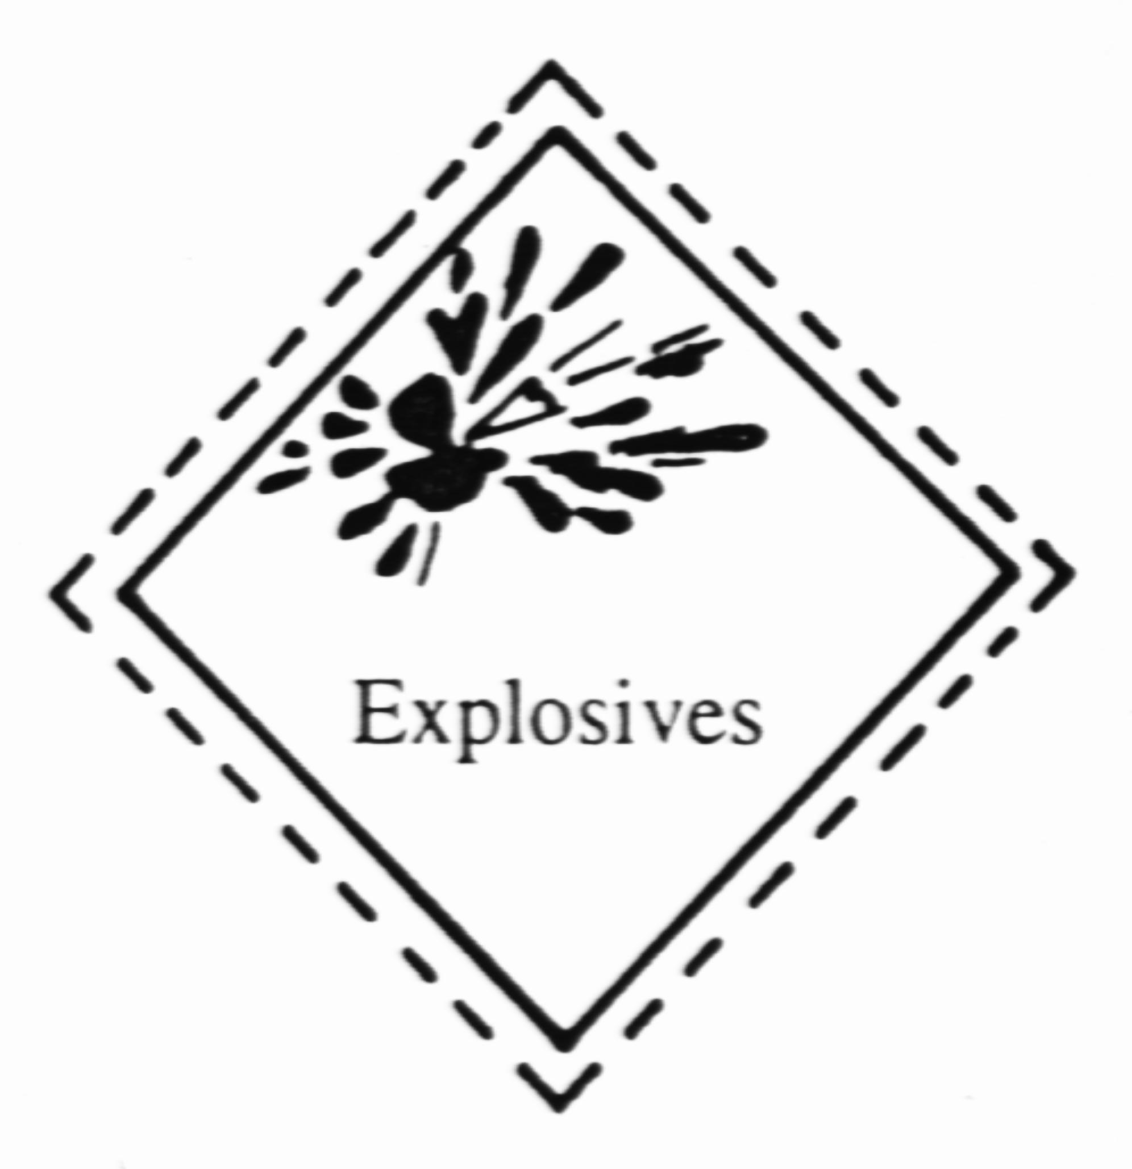
2. | Gases, compressed, liquefied, dissolved under pressure or deeply refrigerated.
 | Inflammable gases  Symbol (Flame) : Black or White  Background : Red | 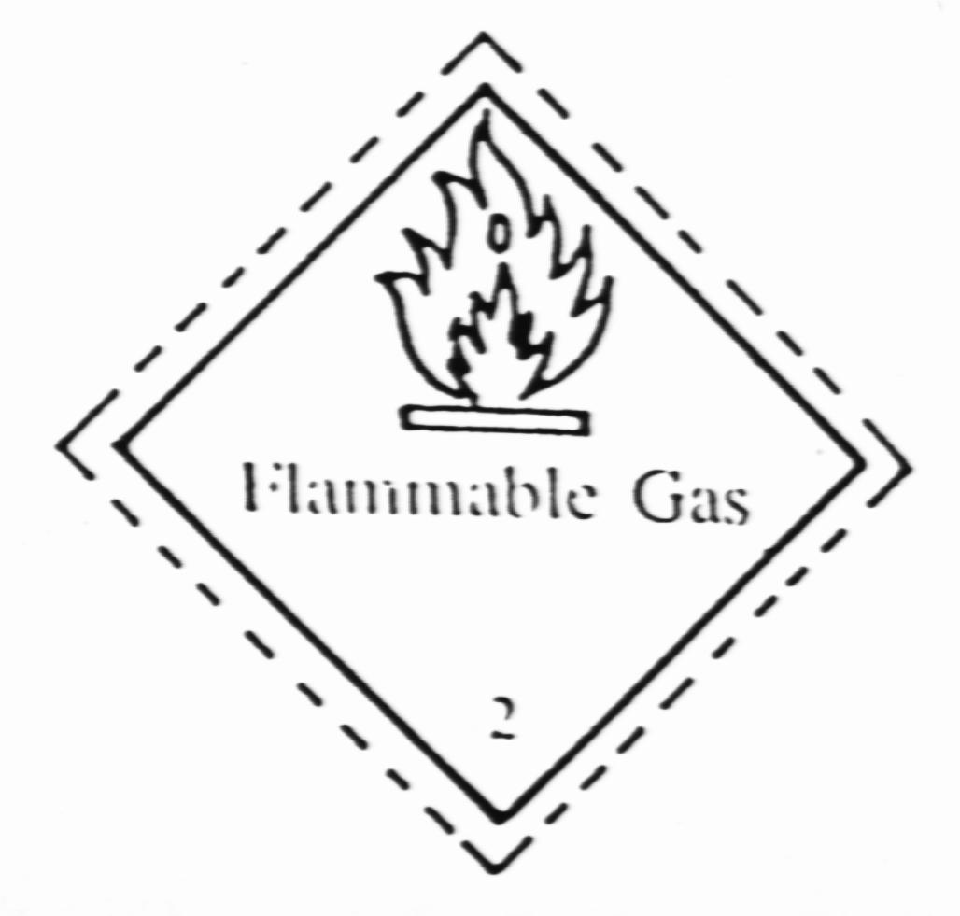
 | Poisonous gases  Symbol (Skull and Crossbones) : Black  Background : White | 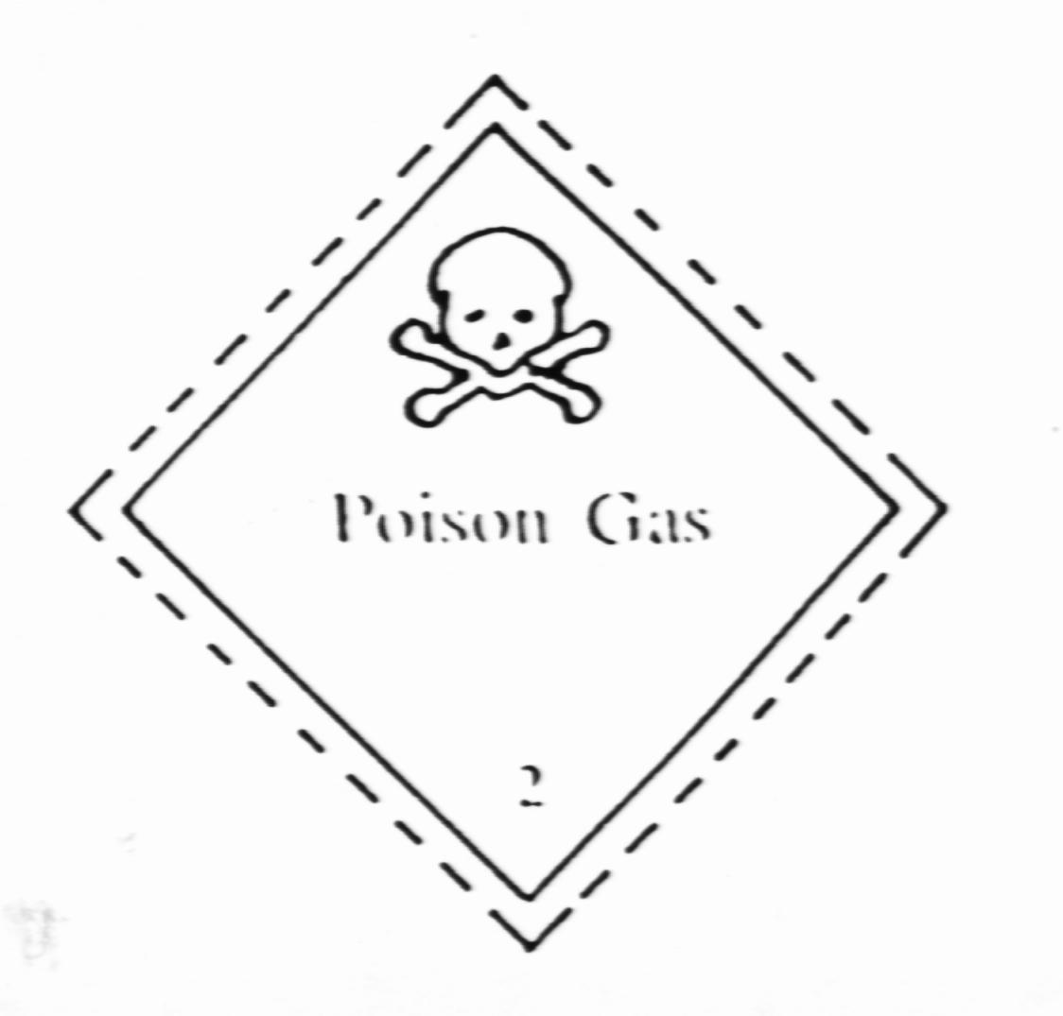
3. | Inflammable liquids  Symbol (Flame) : Black or White  Background : Red | 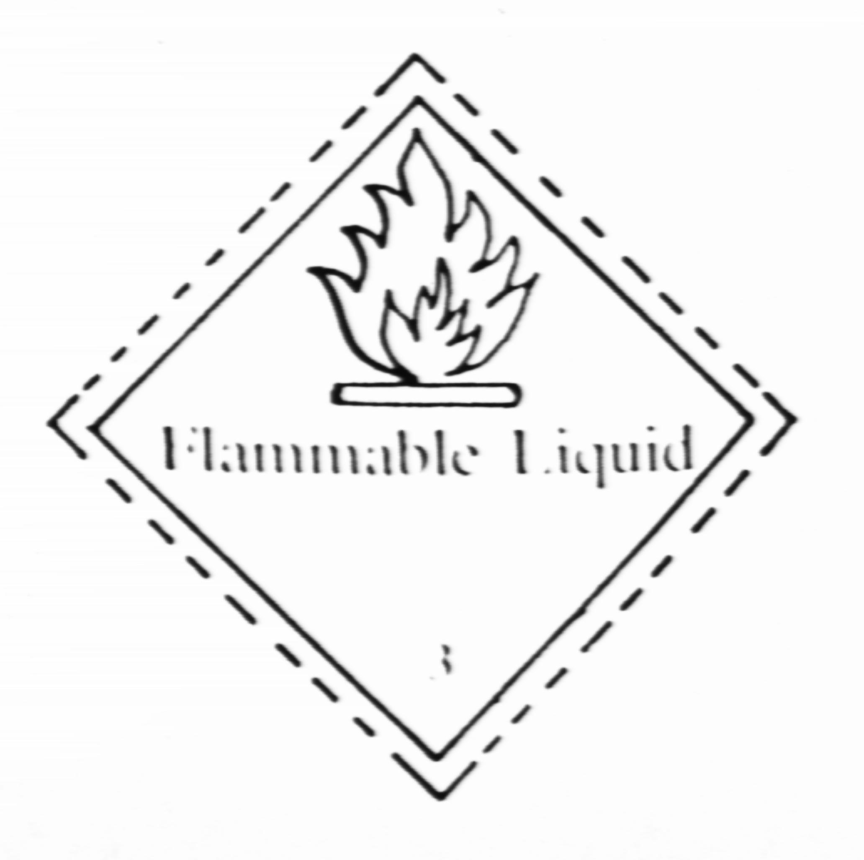
4. | Inflammable solids, substances liable to spontaneous combustion; substances which on contact with water emit inflammable gases.
4.1 | Inflammable solids  Symbol (Flame) : Black  Background : White with vertical red strips | 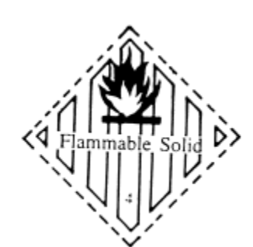
4.2 | Substances liable to spontaneous combustion  Symbol (Flame) : Black  Background : Upper half white  Lower half red | 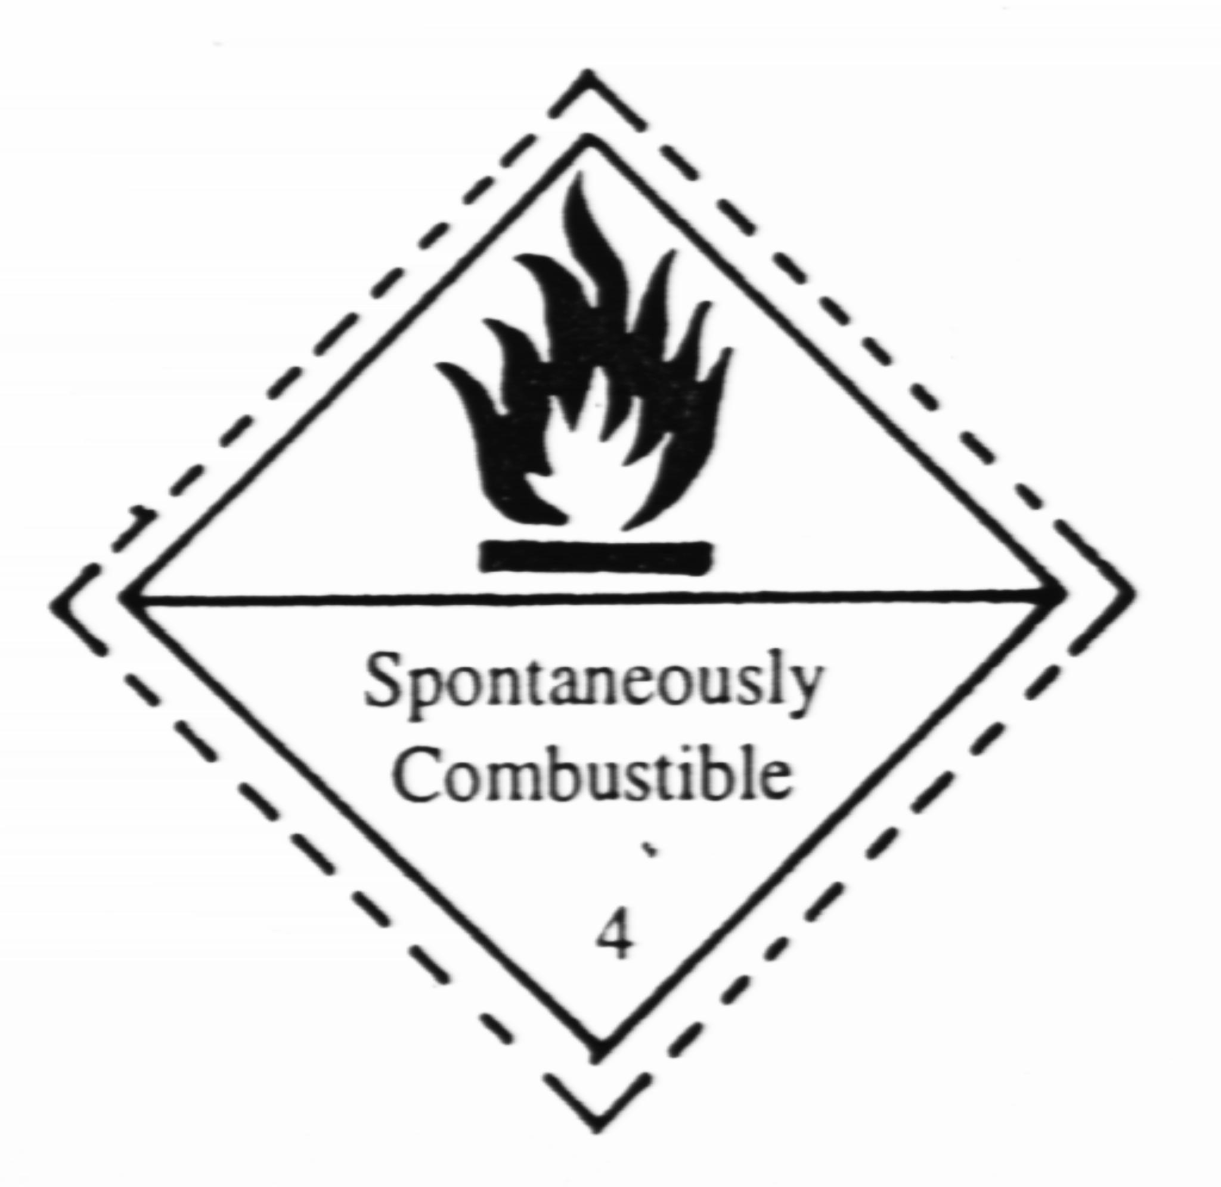
4.3 | Substances which in contact with water emit inflammable gases.  Symbol (Flame) : Black or White  Background : Blue | 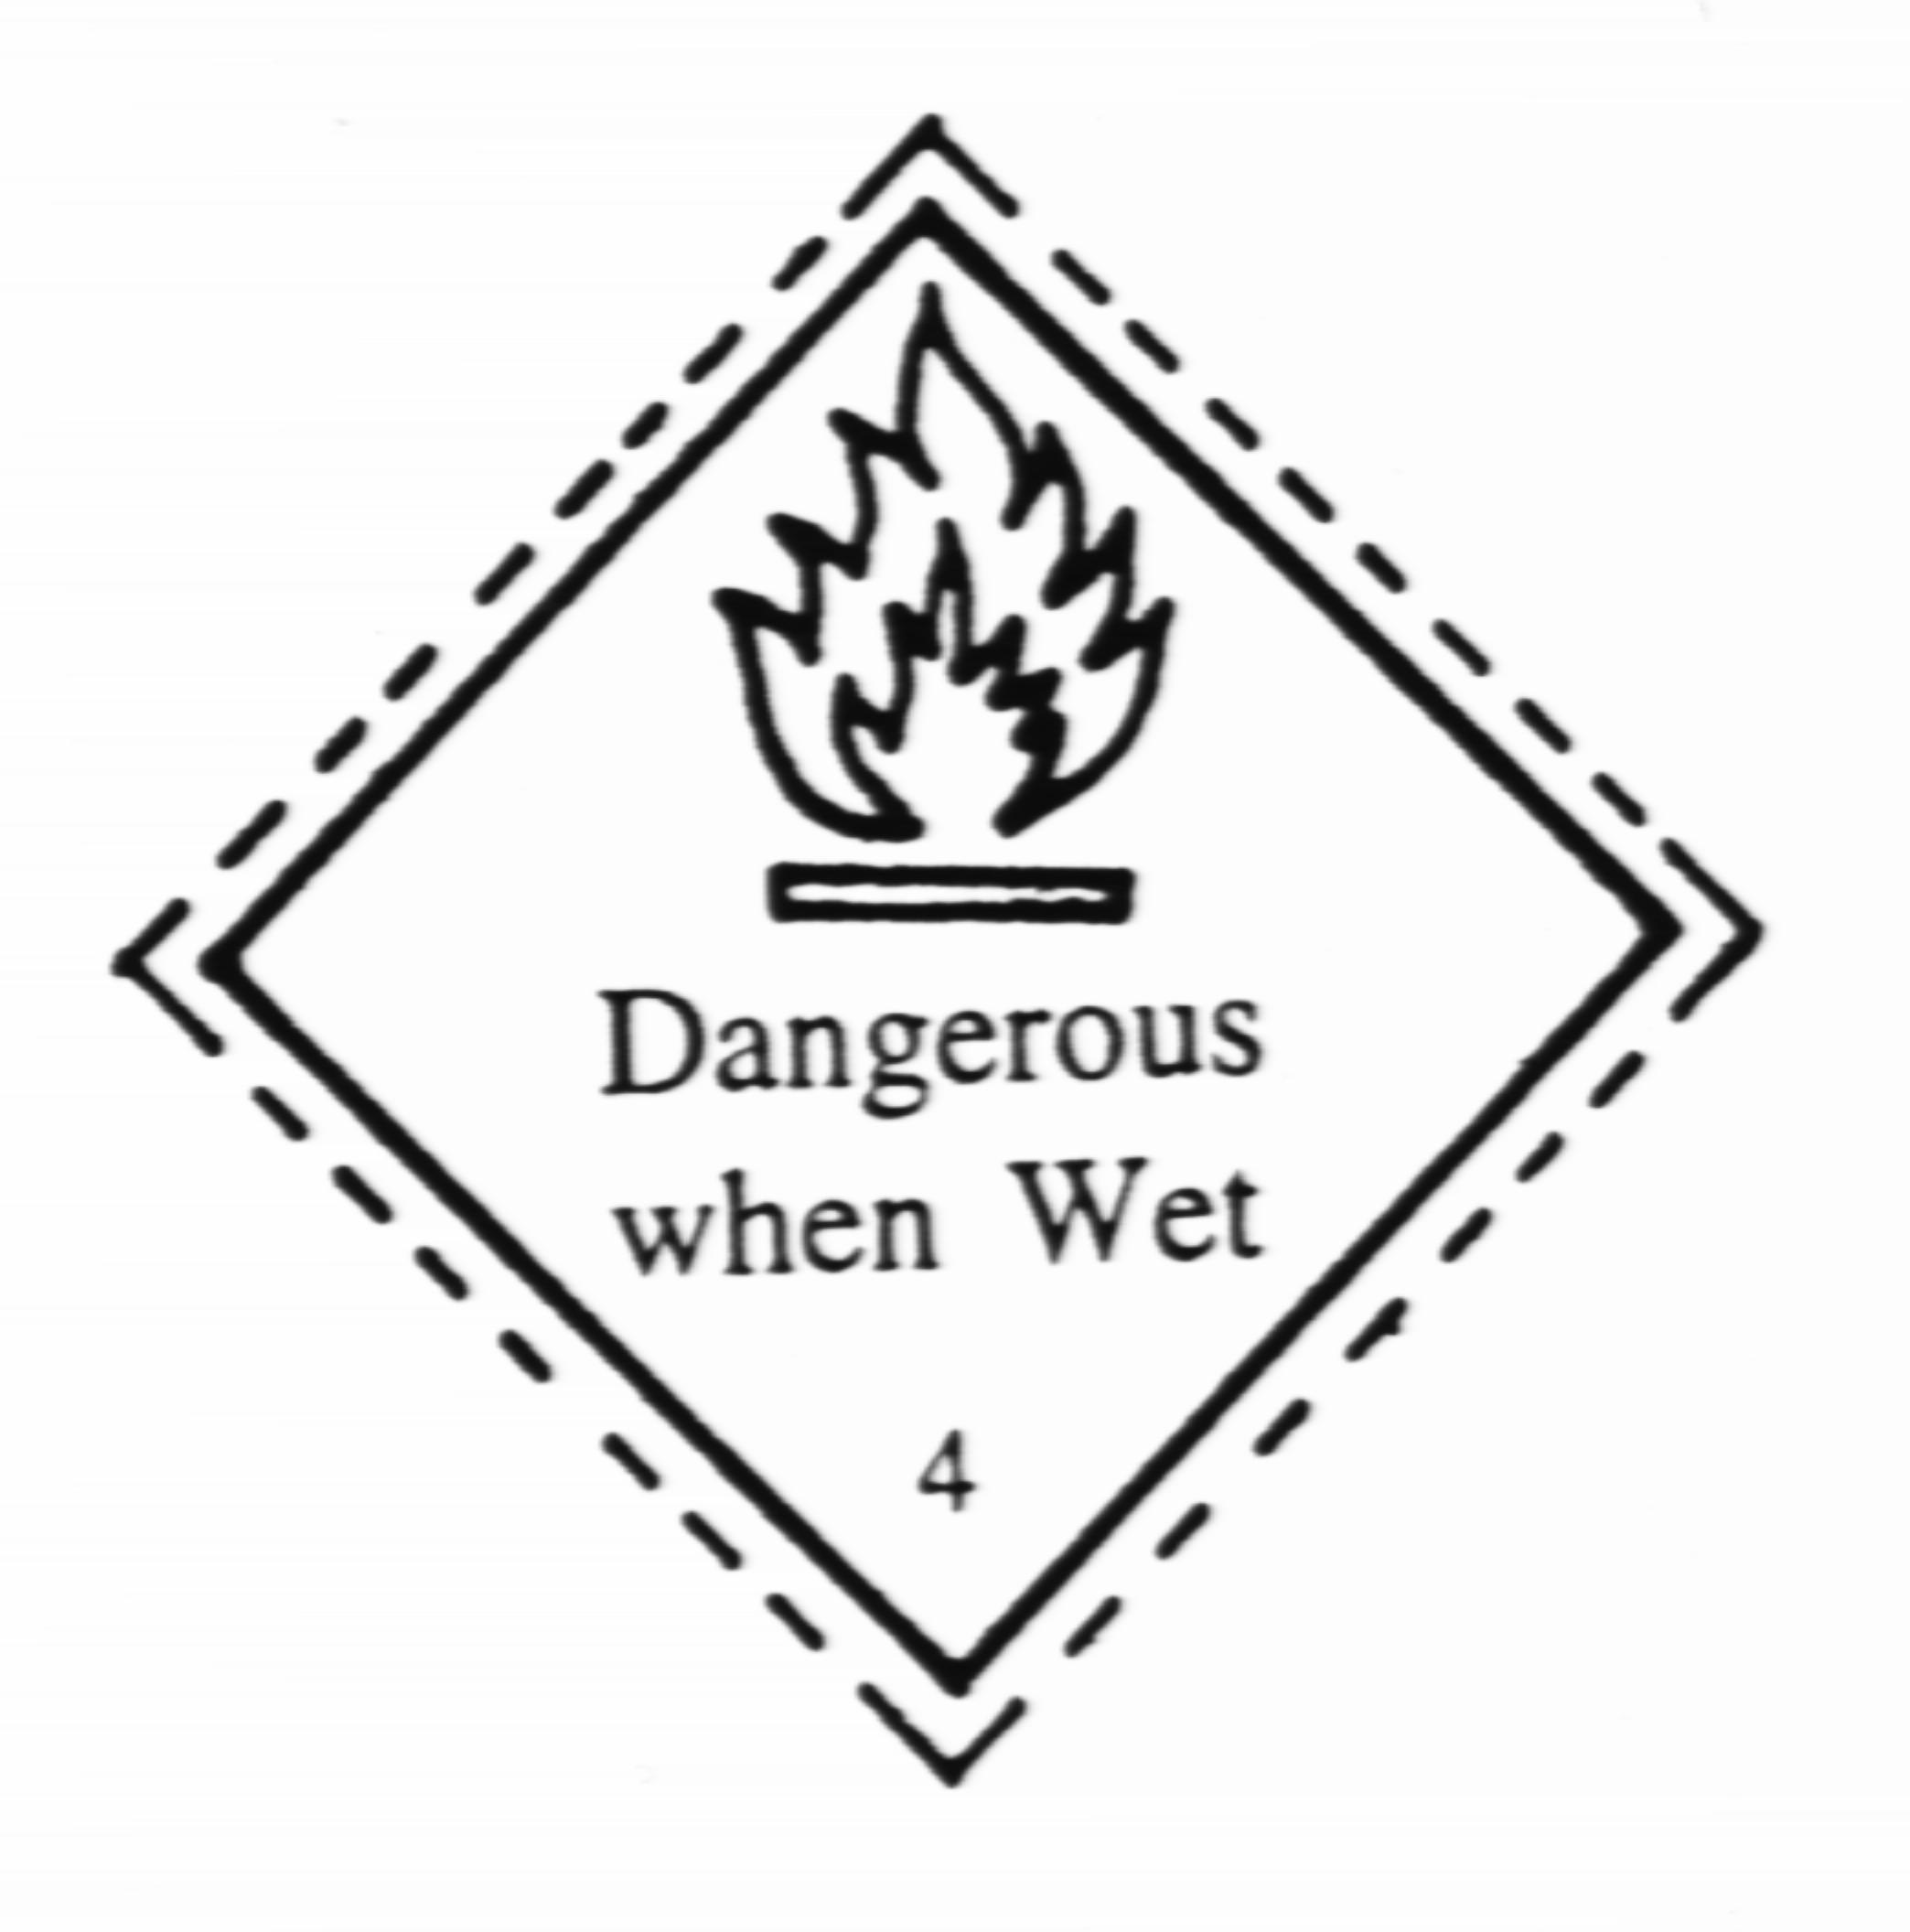
5. | Oxidizing substances (agents) and organic peroxides
5.1 | Oxidizing substances (agents)  Symbol (Flame over circle) : Black  Background : Yellow | 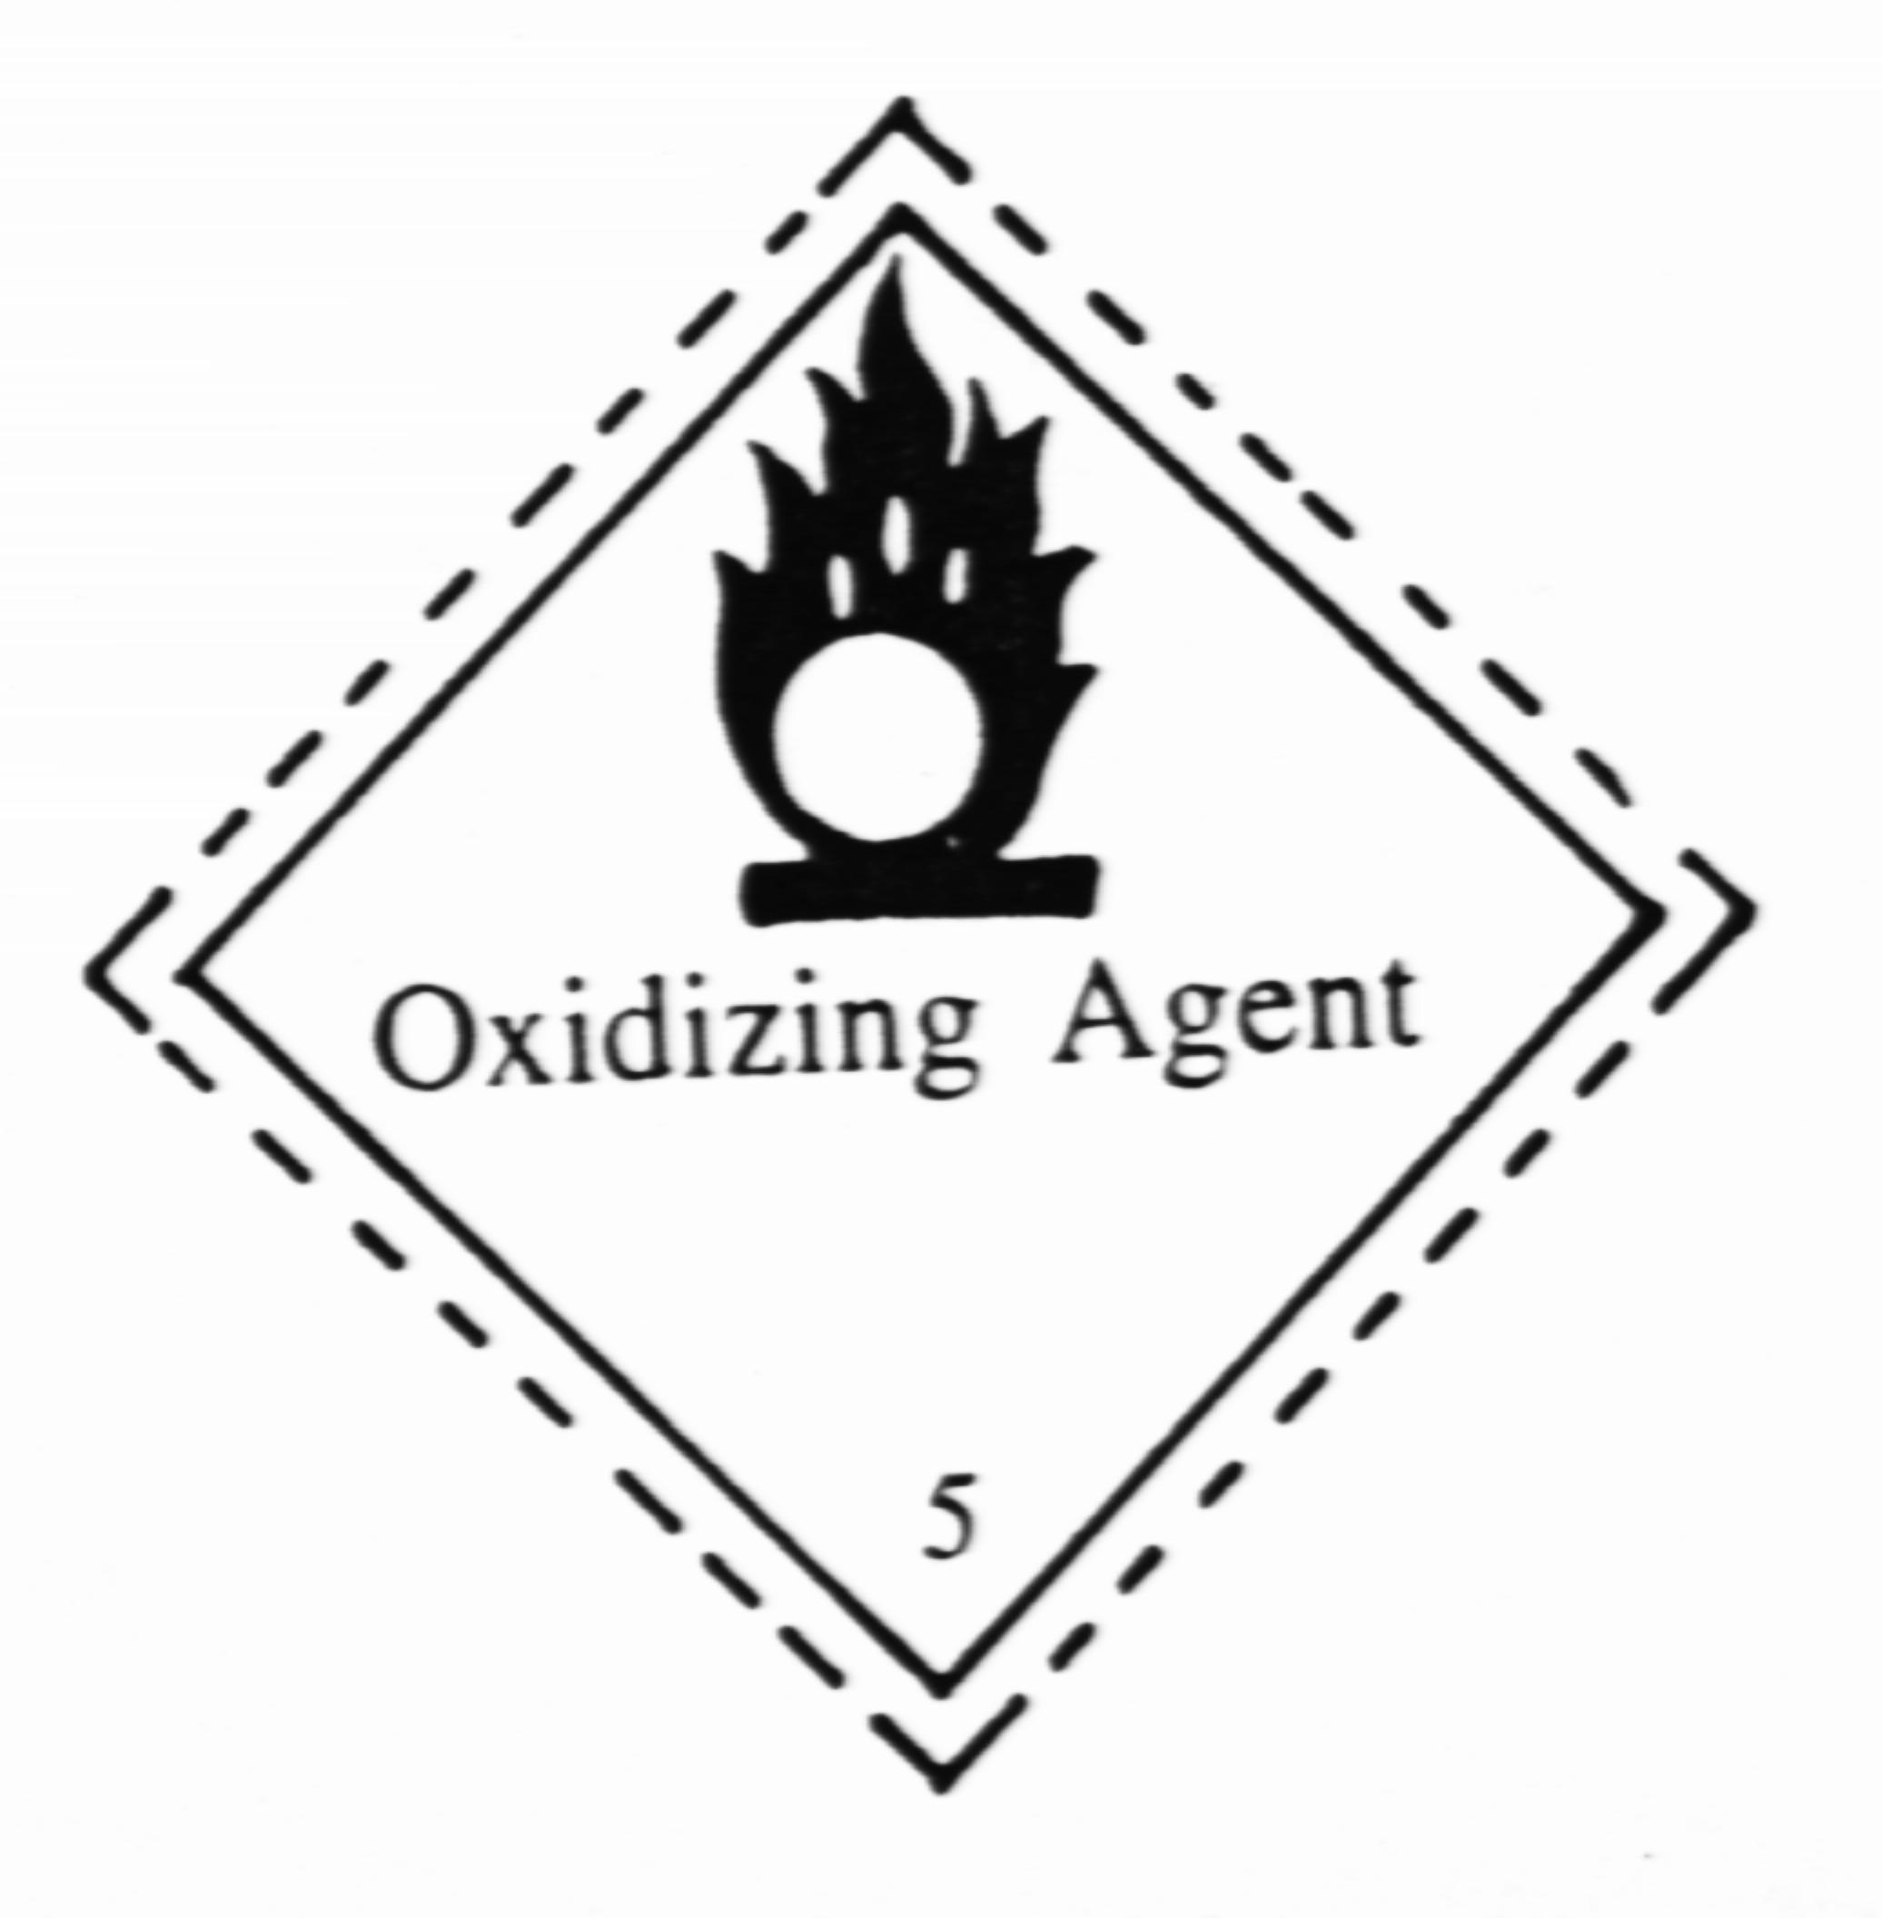
5.2 | Organic peroxides  Symbol (Flame over circle) : Black  Background : Yellow | 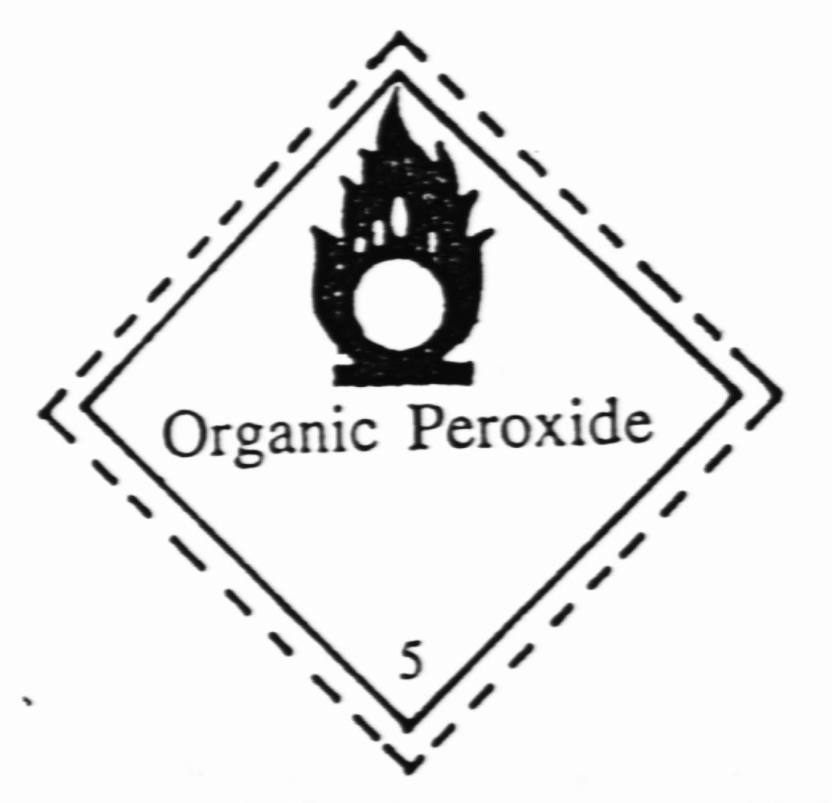
6. | Poisonous (toxic) and infectious substances
6.1 | Poisonous (toxic) substances  Symbol (Skull and Crossbones) : Black  Background : White | 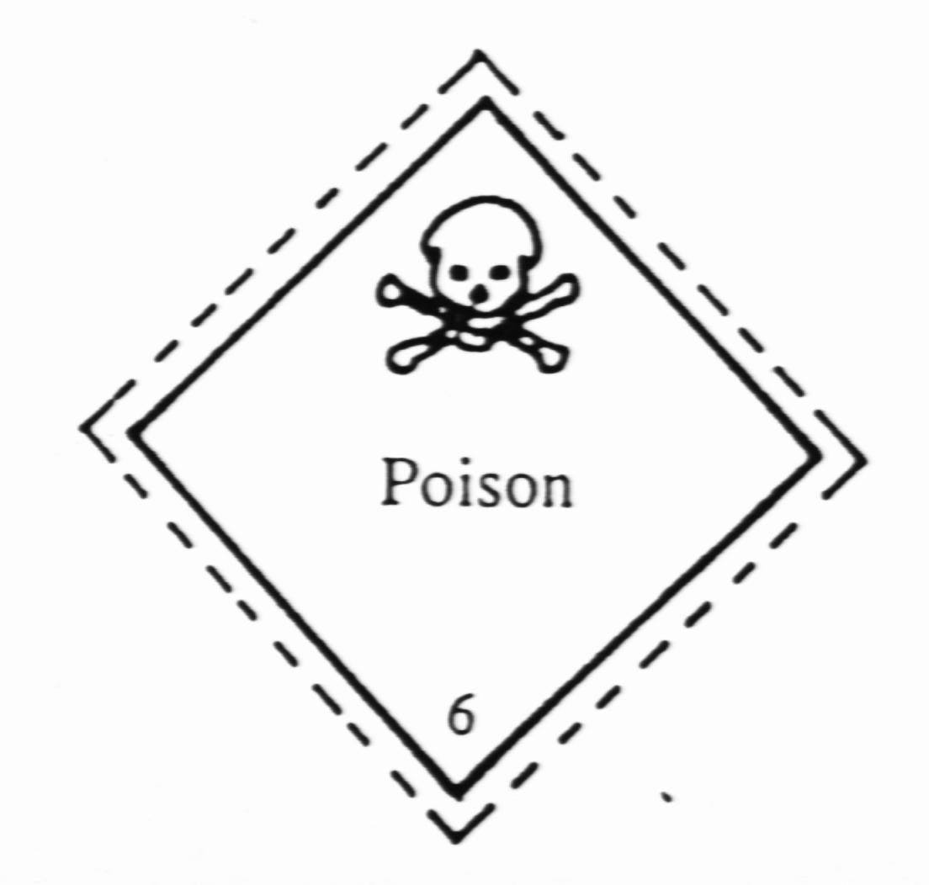
6.2 | Harmful substances  The bottom half of the label should bear the inscription:  HARMFUL  Stow away from foodstuff  Symbol (St Andrews Cross over an ear  of wheat) and inscription : Black  Background : White | 
6.3 | Infectious substances  The bottom half of the label should bear:  INFECTIOUS SUBSTANCES (Optional)  And the Inscription  “In case of damage or leakage immediately notify Public Health Authority” (optional)  Symbol (three crescents superimposed on a circle) and Inscription : Black  Background : White | 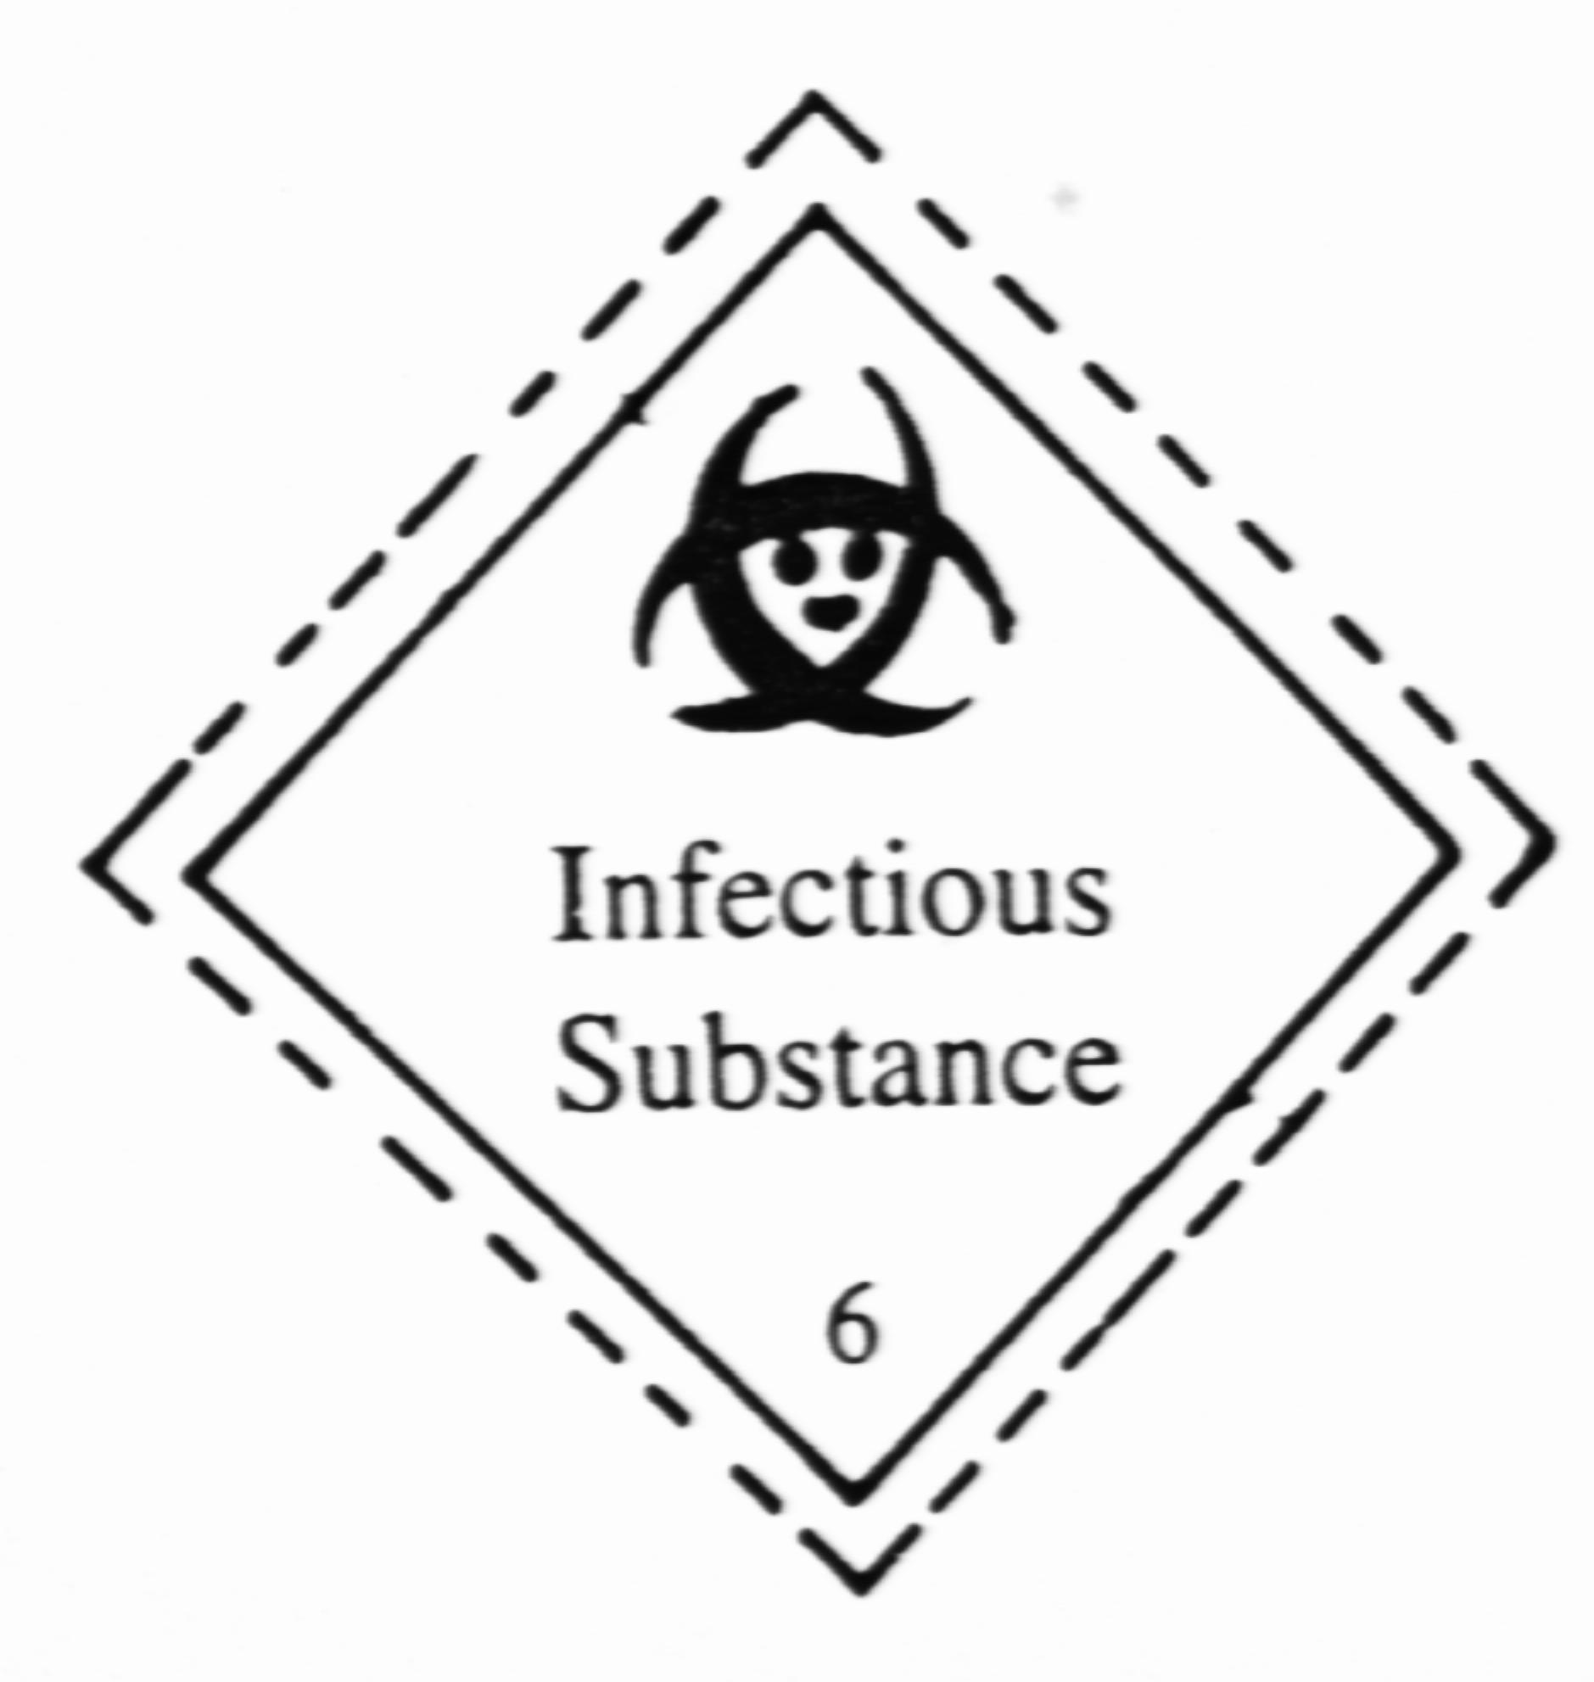
7. | Radioactive substances  Symbol – 3 segments of a circle – a number and letter of the Class label shall be black on a white background and the parallel lines bordering the Class label shall be black and shall be 5 mm thick. | 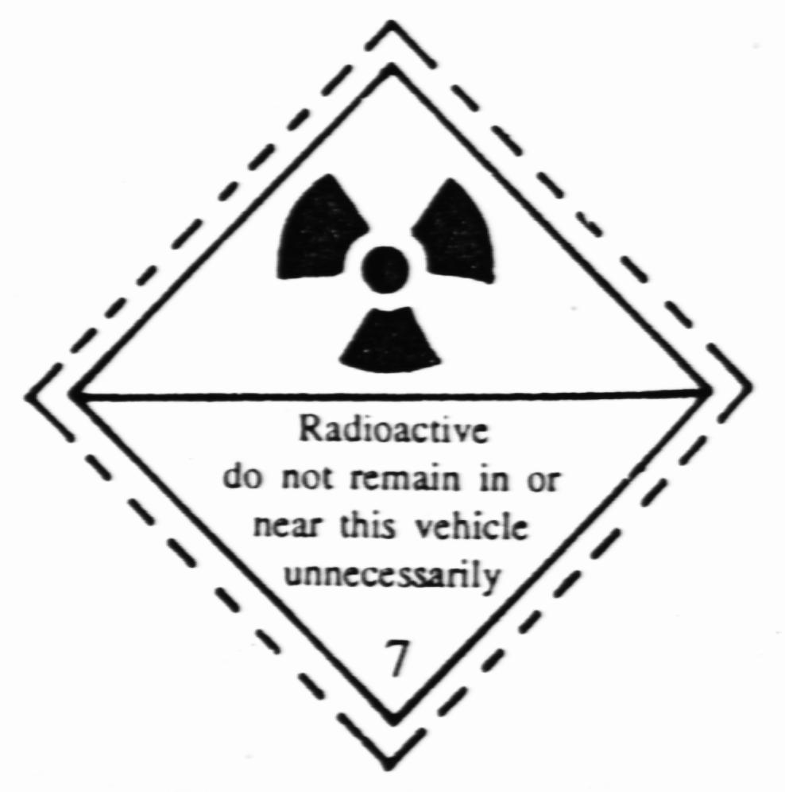
8. | Corrosives  Symbol (liquids spilling from two glass vessels and attaching a hand and a metal): Black  Background: Upper half white  Lower half black with white  Border | 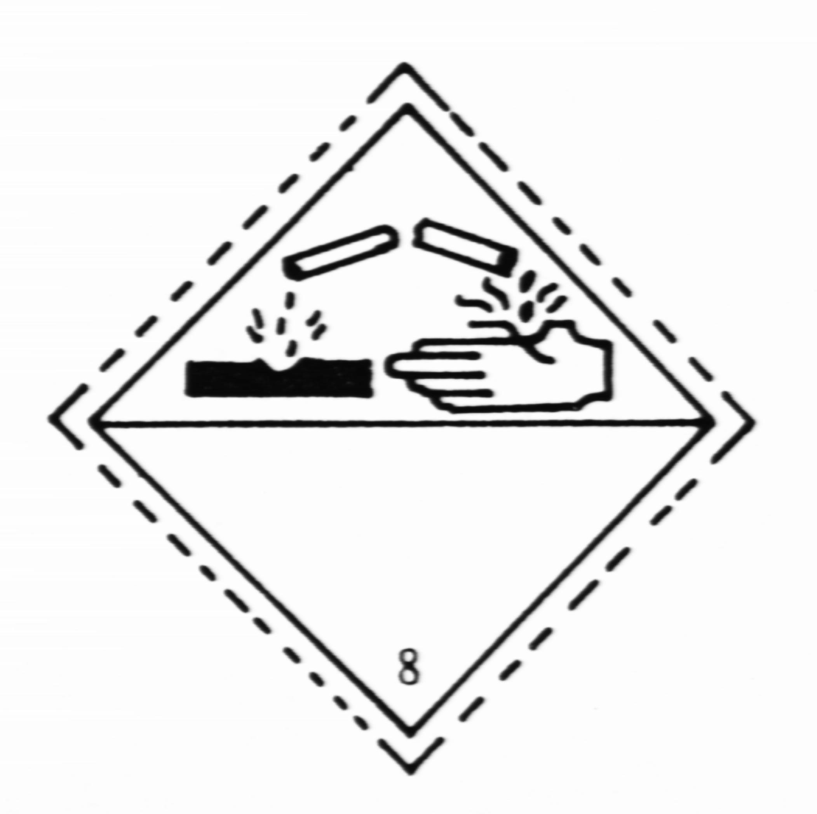

SIXTH SCHEDULE
(Regulation 8)

Inventory of hazardous wastes

Date | Name of waste | Quantity generated  (kg or m³) | Quantity stored | Quantity disposed of and place of disposal

………………………….

Name of waste generator

…………………………

Signature

Date ………………………..

SEVENTH SCHEDULE
(Regulation 9)

Consignment note for hazardous wastes

PART I (Consignor)

Name of consignor:…………………………………………………………………….

Address:………………………………………………………………………………..

……………………………………………………………………….…………………

Tel: No: .....................................................................................

Fax No: ..............................................................…...................

Waste stream:……………………………………………………………………………

Description of waste:…………………………………………………………………….

Physical state of waste:Solid/Sludge/Liquid*……………………………………………

Waste Packaging: Pallet container/Canister/Drum/Others (please specify)*

……………………………………………………………………………………………

Quantity: ..........……………………………………………………………. (in kg or m³)

Treatment plant/disposal site:……………………………………………………………..

…………………………………………………………………………………………….

Delivery date: ............………….....

---------------------------------
Signature of consignor

----------
*Delete as appropriate

PART II (Carrier)

Name of carrier :…………………………………………………………………………..

Address:…………………………………..............................................................................

………………………………………………………………………………………………

Tel. No: .....................................................................................

Fax No: .............................................................…...................…

Vehicle Registration Number :……………………………………………………………

Name of Driver :…………………………………………………………………………..

Temporary storage: If yes, please give address…………………………………………….

………………………………………………………………………………………………

Date received: ............…………..……..

-----------------------
Signature of carrier

PART III (Consignee)

Name of consignee:………………………………………………………………………..

Address:……………………….………….............................................................................

………………………………………………………………………………………………

Tel: No: .....................................................................................

Fax No: ..............................................................…...................…

Type of operation: Storage, Recovery, Landfill, Physico-chemical treatment, Incineration, Others (please specify)*…………………………………………………….

Quantity of waste received: ..................…....……………………………….. (in kg or m³)

Date received: ............………….....

-----------------------
Signature of consignee

___

*Delete as appropriate

